**Feature Matching**

# [Difference between Brute-Force Matcher and FLANN based Matcher](https://stackoverflow.com/questions/10610966/difference-between-bfmatcher-and-flannbasedmatcher)

Brute-force is slower, but it gets the best matches, that’s because it tries all the possibilities.

FLANN is faster, but doesn’t always get the best matches, yet it will get a good match; find an approximate nearest neighbors.

That’s because [FLANN](http://www.cs.ubc.ca/research/flann/) builds an efficient data structure (KD-Tree) that will be used to search for an approximate neighbour, while [Brute-force Matcher](http://docs.opencv.org/modules/features2d/doc/common_interfaces_of_descriptor_matchers.html#BFMatcher%20:%20public%20DescriptorMatcher) does an exhaustive search and is guaranteed to find the best neighbour. Thus, FLANN is used with large data sets.

# [Difference when](https://stackoverflow.com/questions/10610966/difference-between-bfmatcher-and-flannbasedmatcher) changing the distance function in Burte-Force Matcher and the number of Ks.

Before changing(ratio=0.75)

Figure after changing the distance ratio from 0.75 to 0.9

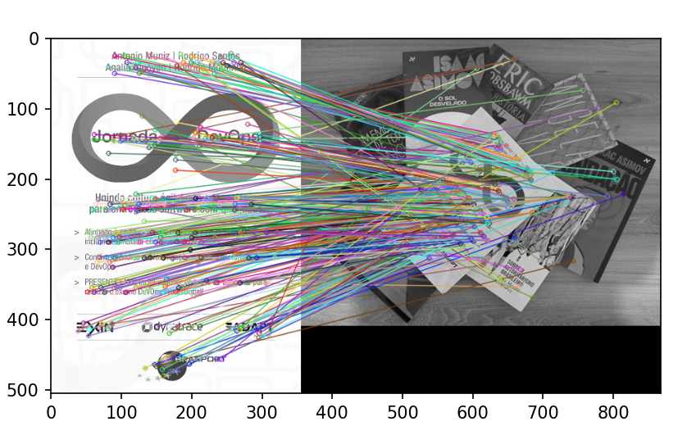

Note: Too many unclear matches occurred, and most of the new matches are wrong; it became less accurate.

Figure after changing the distance ratio from 0.75 to 0.4

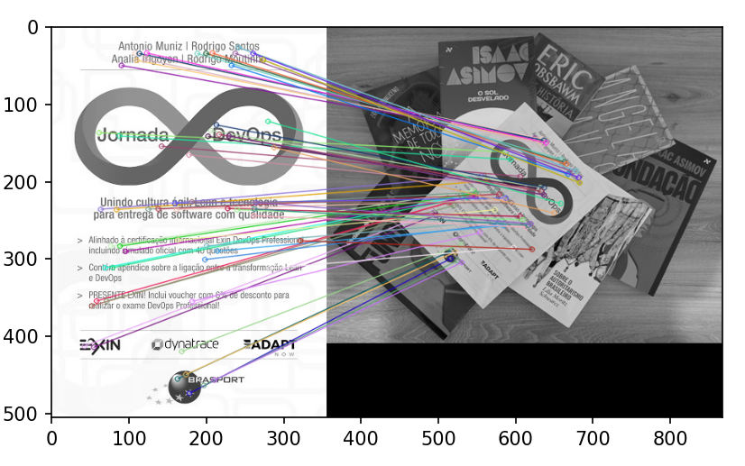

Note: Number of matches is reduced, yet it’s more accurate than the previous trails.

Conclusion: The lower the ratio distance the higher the accuracy, but the lower the number of matches.